Business Requirements document WH Site

Version 1.1

Approved By: __________________________________________________________

Date: ___________________________________________________________

Disclaimers
The information contained in this document is the proprietary and exclusive property of except as otherwise indicated. No part of this document, in whole or in part, may be reproduced, stored, transmitted or used for design purposes without the written prior permission of .

Privacy information
This document may contain information of a sensitive nature. This information should not be given to persons other than those who are involved in the Project Name Client Conceptualization & Realization or who will become involved during the life cycle.

Version History

Version No | Author (s) | Contributor (s) | Version Description | Approved by
V1.0
V1.1
Table of Contents

Section 1.0 GENERAL DESCRIPTION 5
Section 2.0 OBJECTIVES 6
Section 3.0 ERP INTEGRATION 7
3.1 General 7
Section 4.0 SYSTEM CONFIGURATION 7
4.1 Company 7
4.2 Site 8
4.3 Location Groups 8
4.4 Locations 9
4.5 Zones 9
4.5.1 Pick Zone 9
4.5.2 Put Zone 10
4.6 Put/Pick Methods 10
4.6.1 Put Method 10
4.6.2 Pick Method 11
4.7 Rules 11
4.7.1 Pick Rule 11
4.7.2 Put Rule 12
4.8 Order/Receipt Types 13
4.8.1 Order Types 13
4.8.2 Receipt Types 13
4.9 Carrier 14
Section 5.0 Masters 17
5.1 SKU 17
5.2 SKU UOM/SIZE 18
5.3 SKU Alias 18
5.4 Vendor 19
5.5 Consignee 19
Section 6.0 Transaction Downloads 19
6.1 Purchase Orders, Stock Transfer In, Return Sales Orders, Swap PO 19
6.2 Sales invoices (SO), Swap Sales Order, and Stock Transfer Out. 20
Section 7.0 Transaction confirmations 20
7.1 Inbound Confirmations 20
7.2 Outbound Confirmations 21
7.2.1 Outbound Confirmation at Pick Level 21
7.2.2 Outbound Confirmation at Trailer Depart 21
7.2.3 Outbound Confirmation at PoD (Proof of Delivery) 22
Section 8.0 INBOUND OPERATIONS 22
8.1 Receiving 22
8.2 Check-In and Breakdown through Screen 25
8.3 RF Check-In and Breakdown 26
8.4 “Cross Docking” for Pre-Sold Orders (Backorders) 29
8.5 Put Away (System Directed) and Storage 30
8.5.1 Two Step Putaway 30
8.5.2 Putaway to Transfer Location 31
8.5.3 Putaway to End location 31
Section 9.0 OUTBOUND OPERATIONS 32
9.1 Order Processing and Wave Management 32
9.2 Wave Creation 32
9.3 Wave release 33
9.4 Order Picking 34
9.4.1 Two Step Picking 36
9.4.2 Picking from Bulk Location to Transfer Location 36
9.4.3 Picking from Transfer location to Staging Location 36
9.5 Packing 37
9.6 Shipping 37
Section 10.0 CYCLE COUNTING AND INVENTORY MANAGEMENT 39
10.1 Cycle Counting 39
10.2 Replenishments 42
10.3 Inventory Management 42
10.3.1 Stock transfers 42
10.3.2 Inbound process 43
Section 11.0 REVERSAL (RRLC) 43
11.1 Reversal 43
11.2 Sales Order Cancellations 44
11.3 Swapping 44
Section 12.0 Enhancements 46

Section 1.0 GENERAL DESCRIPTION

Section 2.0 OBJECTIVES

Client identified the following goals and ROI objectives resulting from implementing eBizNET.

- Reduce Order Lead Time.
- Increase operational visibility via enablement of KPI’s/ metrics
- Improved Space Utilization
- Improve Inventory Accuracy and Control. Through utilizing system directed putaway, order fulfilling and cycle counting via RF terminals, CLIENT will more accurately account for inventory and improve visibility of inventory within the facility.
- Improve Labor Utilization. CLIENT will realize improved labor utilization in receiving, put away, order filling and packing. Utilizing system directed put away will reduce the amount of time required to locate a storage location for the incoming product. Product will be system directed to random storage locations and the storage locations will be instantly updated in eBizNET.
- Improve Order Accuracy. Through utilizing RF terminals by scanning pick locations during the orderfilling process, improved order accuracy will be attained.

Section 3.0 ERP INTEGRATION

3.1 General

eBizNET will build an interface structure between Client’s existing ERP and eBizNET . will take responsibility to ensure that these interfaces will reliably pass information between the two systems as described in this section.

Client will have the discretion of determining when specific interfaces will be scheduled or executed. For the inbound interfaces the data will be transferred from ERP to the Intermediate Tables of eBizNET and from there the eBizNET interface engine will process the data and then create appropriate data in the eBizNET system. For Outbound the data will be provided in the CSV format to the ERP.

Section 4.0 SYSTEM CONFIGURATION

This section describes how and what are the screens used to configure the master data.

WH Warehouse is classified into single site in ebizNET. Client will be added as the Company. Another company will be added to the same site with the start of 3PL operations.

Warehouse will be logically divided into different zones, location groups and locations.

4.1 Company

eBizNET will hold inventory for company – Client – under company code – SS. Client can create multiple companies when 3PL warehouse is functional.

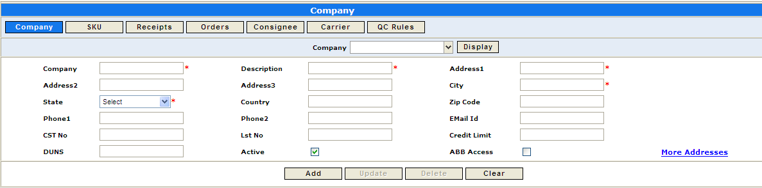

4.2 Site

The largest classification of locations is by Site. In eBizNET, one company can have multiple sites. For SS, inventory will be in WH Chennai Warehouse. Once the 3PL operations are functional, additional companies can be added in eBizNET to the existing site. Configuration to support access for users to tasks of multiple companies if required. In existing warehouse if additional 3PL customers are added, do we need to define another site.

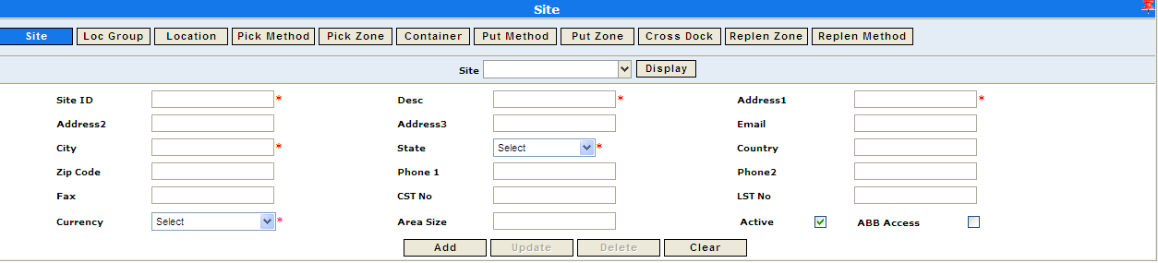

4.3 Location Groups

Sites are broken down further by Location Groups. There can be one or many Location Groups in a site. The attributes of the Location Group will be assigned to an individual location. The Location Group must be unique within a site.

To optimize warehouse space, overflow of location groups concept will be used, so that one location group can accommodate multi product line SKUs, if required. Location groups are classified into

- Staging Location groups (Inbound)
- Staging Location groups (Outbound)
- MRP labeling and packing
- Pallet Racking (For Medium parts, caged or normal pallet)
- Shelving area (For small parts, storage in bin shelving)
- Pick face in Racks (Set of lower as well as higher locations)
- Block storage on ground ( For Bulkier parts)
- Inspection area, Returns area and Damaged goods area
- Transfer Locations
- Static Locations (Trolleys)

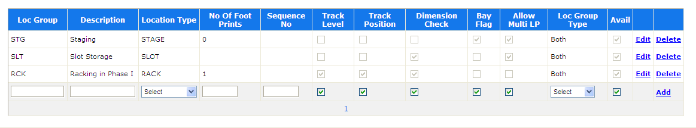

4.4 Locations

Locations at Client can be broadly classified into VNA Racking locations, Shelving locations, Staging Locations, Bulk locations, Transfer locations and Static locations.

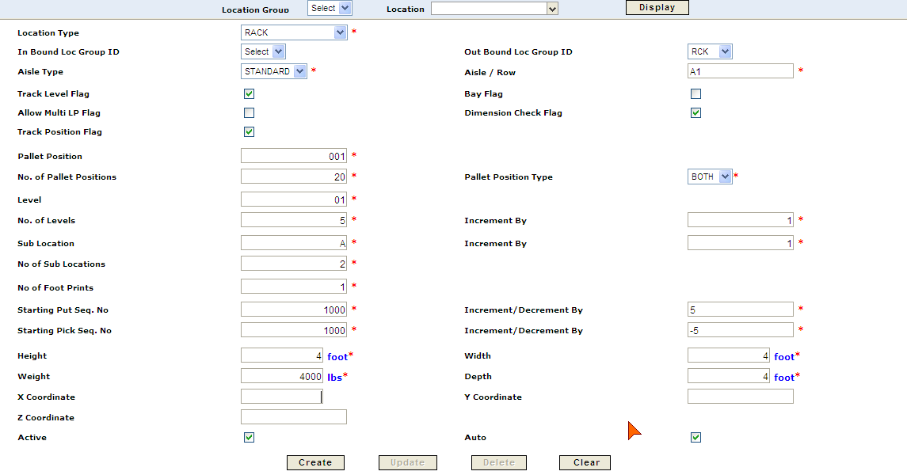

4.5 Zones

Zone is group of location groups. At Client, zones can be further classified into Put Zone, Pick Zone and Replenishment Zone.

4.5.1 Pick Zone

A Pick Zone is not a physical line, but a method in which the items are to be picked. Many characteristics will be combined to define the way in which picks occur from the assigned Pick Line, and these characteristics are defined at Pick Zone Level.
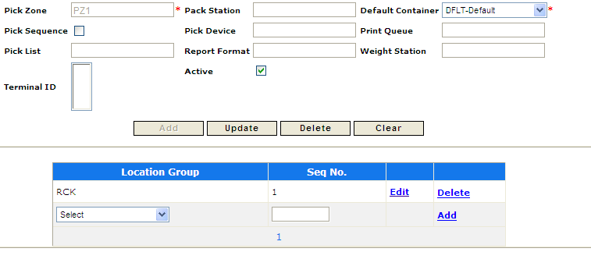

4.5.2 Put Zone

A Put Zone is not a physical line, but a method in which the items are stored in warehouse (Putaway). Many characteristics will be combined to define the best possible way to putaway the products

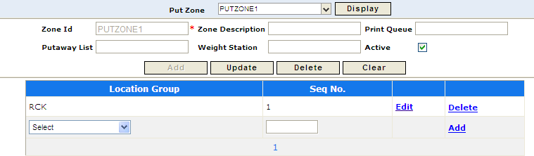

4.6 Put/Pick Methods

4.6.1 Put Method

The Put Method defines the characteristics of locations that need to be searched when looking for a putaway location.
Each Location Group/Zone can have multiple Put Methods and one method may be applied to multiple Location Groups/Zone. The location assignment process will use the put method and return the most desirable location that satisfies the rule. The put method may be any combination of the following:
- Dimension
- Empty Location
- Merge
  - Mix Lots
  - Mix Pack Code
  - Mix SKU
- Allow Split
- Merge LP

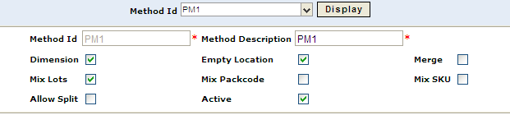

4.6.2 Pick Method

Pick methods can be configured for order picking or for cluster picking. Cluster attributes will determine how many clusters should be created for one wave.

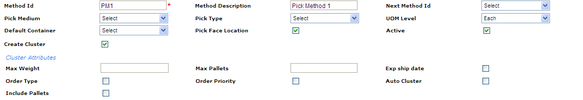

4.7 Rules

4.7.1 Pick Rule

The Pick Rule will be defined based on the characteristics of SKU that need to be searched when looking for a pick location using Pick method, and other parameters. Pick rule also determine the sequence of the path a SKU should be picked from.

- Pick Zone
- Pick method
- Location Group
- SKU Family
- SKU group
- SKU
- SKU Status
- SKU Velocity
- UOM Level
- Order type
- Sequence No

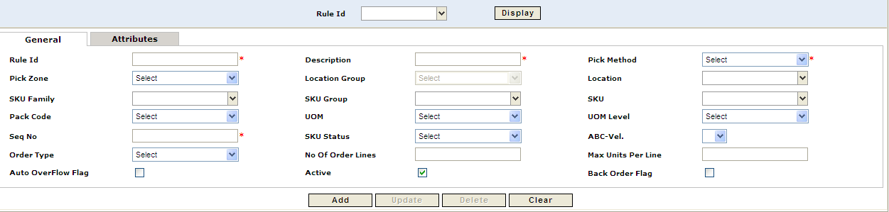

4.7.2 Put Rule

The Put Rule defines the characteristics of SKU that need to be searched when looking for a putaway location based on Put method. Put rule also determine the sequence of the paths a SKU should be putaway to the location.
- Put Zone
- Put method
- Location Group
- SKU Family
- SKU group
- SKU
- SKU Status
- SKU Velocity
- UOM Level
- Receipt Type
- Sequence #
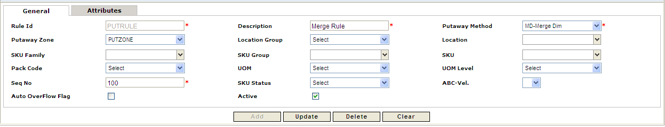

4.8 Order/Receipt Types

4.8.1 Order Types

Every order in eBizNET must be assigned an Order Type. For Client, this will be sent from the Host system in the inbound order interface. Order type will be the key indicator which drives how that order will be processed and also determines what kind of paperwork need to be printed.
Below is the list of Order Types for Client:

COMPANY CODE | ORDER TYPE | DESCRIPTION | Stock
SS | SO | Sales Invoice | Saleable
SS | STO | Stock Transfer Out | Saleable
SS | SWO | SWAP OUT | Saleable
SS | VRET | Vendor Returns | RTM
SS | MIO | Miscellaneous Issue | Any
SS | RSTO | RTM Stock Transfer | RTM
SS | INSO | Insurance Order | Damage

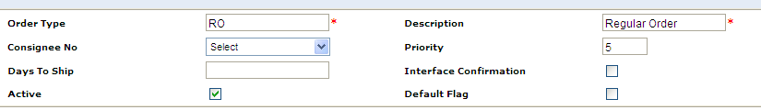

4.8.2 Receipt Types

Every receipt in eBizNET must be assigned a Receipt Type. For Client, this will be sent from the Host system in the inbound PO interface. Receipt type will be the key indicator which drives how that receipt will be processed and also determines what kind of paperwork need to be printed.

Below is the list of Receipt Types for Client:

COMPANY CODE | RECEIPT TYPE | DESCRIPTION | Stock
SS | PO | Purchase Order | Saleable
SS | RET | Returns | RTM
SS | SWI | SWAP In | RTM
SS | STI | Stock Transfer In | Saleable
SS | IMP | Imports | Saleable
SS | RSTI | RTM Stock Transfer In | RTM
SS | MI | Miscellaneous Issue | Any

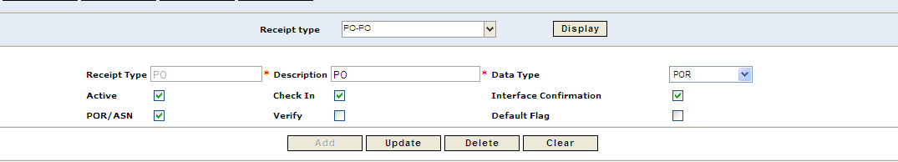

Right now there is no provision to track the serial numbers based on the Receipt Type. One more flag will be added in the Receipt Type screen and that will determine whether the PO with this Receipt type has the Serial Number tracking for the SKU’s which are having Serial Numbers.
Option to choose Scanning at
- Inbound and outbound
- Only Outbound.
- DOA returns

4.9 Carrier

Carriers will be pre defined in eBizNET as per ERP. Orders transmitted to eBizNET will come along with Carrier information. Carriers are usually determined based on the Route and destination. Multiple carriers are used at Client for shipping orders.

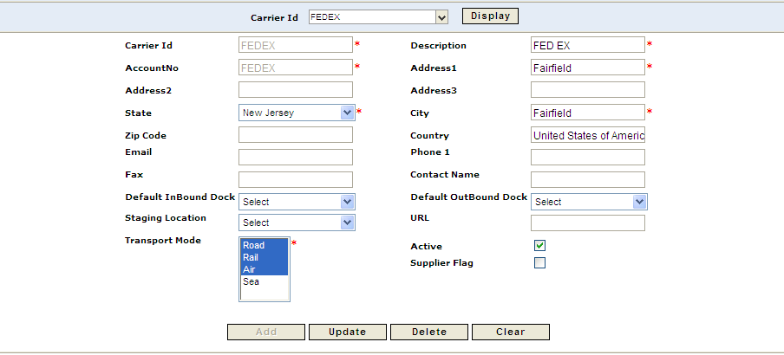
DIVISIONS
Client’s businesses are broadly classified into two, based on the categories of products handled by the company.
- IT Businesses
While the IT arm deals in mostly IT-related hardware like servers, printers etc, and the Non-IT arm distributes white-goods like refrigerators, air-conditioners, mobile phones and portable music players
In Chennai warehouse are divided in to
    - Regional Warehouse/Chennai Warehouse-
Also, called the Chennai Warehouse, it caters to the sales to districts in and around Chennai. It is the primary warehouse for billable sales for the region. It handles IT-related hardware only.
    - National Warehouse – mostly stock transfers
This Chennai Mother-Warehouse acts as a hub for receiving, storing and distributing primarily imported goods. The distribution part is largely confined to stock transfers to other Regional Warehouses through-out the country, including Chennai Warehouse

Currently the three warehouse sites is three separate warehouses physically. In Chennai WH they will be merged into one warehouse. In ERP they will continue to exist as three separate sites.

Basic activities which happens in ware house include
- Inbound
In bound normally includes
- Stock transfer
- Purchase
- Sales returns
- Add on processes for import (MRP Stickering, Testing)
- SWAP IN
- Returns

- Storage
In this activity basically storage of product takes place.
- Outbound
Can be classified in to
- Sales
- Stock transfer
- Returns
- SWAP Out

1,5,8 should be in one ‘Saleable’ Zone. All other stock rooms(2,3,4,6,7, will have separate zones.

In this hierarchy we have Client as the owner. Here we can treat both Client and third party as company. In this hierarchy site normally refer to warehouse. There is a logical division called zone. Location group normally refer to group of locations in the ware house. All the pallets in the warehouse are considered has different locations. Each location will be having one or more sub locations which can be treated as bin/shelf.

Section 5.0 Masters

5.1 SKU

All the ERP codes are identified as SKU’s in eBizNET. All the SKUs will be created first in the ERP and then downloaded into eBizNET. No SKU will be created directly in eBizNET. The SKU master information will be inserted into the eBizNET SKU intermediate table and then the eBizNET engine will process the SKU and create the SKU Master.

All ERP code creation and updation will be an integration touch point. ERP code changes for products will be handled through integration. Miscellaneous issue and receipt in ERP is integrated for putaway and picking.

For the kitting SKUs Bill of Material will be downloaded from ERP to the eBizNET. Right now there is no standard interface exists for the Bill of Material, and needs to do the customization for this.

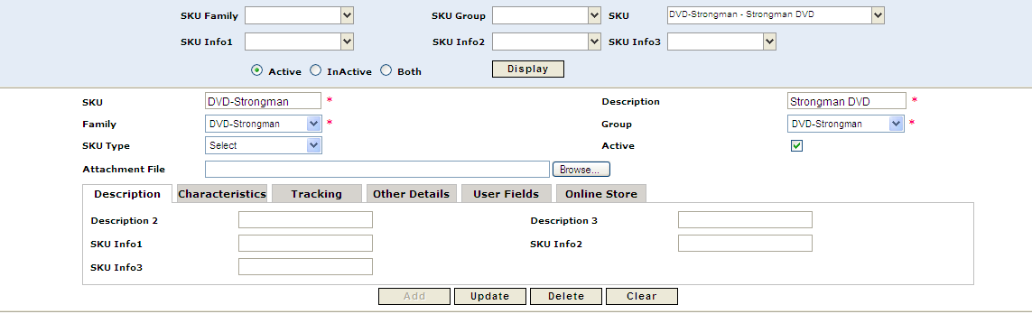

5.2 SKU UOM/SIZE

Dimensions may not be available at the time of creation of SKU in ERP hence dimensions will not be created with the download of SKU to eBizNET. So the Dimensions will be inserted in eBizNET, when the SKU is physically received in the warehouse.

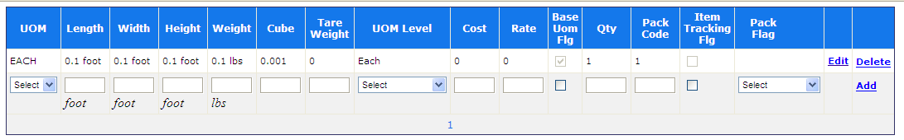

5.3 SKU Alias

Vendor codes from ERP are stored in eBizNET as SKU Alias. Vendor codes will be downloaded to eBizNET through SKU interface.

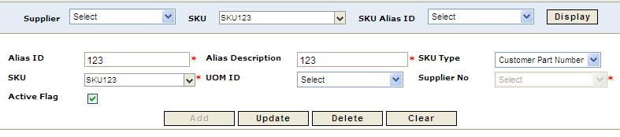

5.4 Vendor

All vendor data will be created and maintained in ERP and will be interfaced to eBizNET via the Vendor interface. Vendor information will be directly inserted into the eBizNET Vendor intermediate table and from there the data is processed and Vendor Master is created in eBizNET.

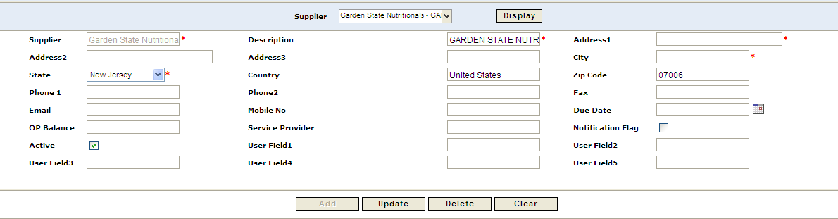

5.5 Consignee

All consignee/customer data will be created and maintained in ERP and will be interfaced to eBizNET via the customer interface. Consignee information will be directly inserted into the eBizNET Consignee intermediate table and from there the data is processed and Consignee Master is created in eBizNET.

eBizNET also creates Consignee information – dynamically – when a new consignee is downloaded along with Sales Orders(Invoices).
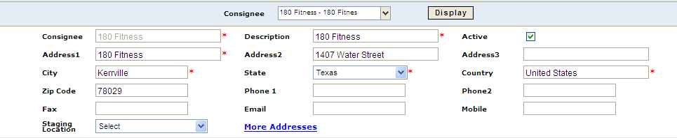

Section 6.0 Transaction Downloads

6.1 Purchase Orders, Stock Transfer In, Return Sales Orders, Swap PO

All the POs, Stock Transfer Inward, Return Orders will be entered in ERP. None of them will be entered into eBizNET directly. All will be downloaded into eBizNET with different type of Receipt.

COMPANY CODE | RECEIPT TYPE | DESCRIPTION
SS | PO | Purchase Order
SS | RET | Returns
SS | SWI | SWAP In
SS | STI | Stock Transfer In
SS | IMPI | IMPORTS
SS | RTSI | RTM Stock Transfer In

6.2 Sales invoices (SO), Swap Sales Order, and Stock Transfer Out.

Sales Invoices (SO), Swap Sales Order, and Stock Transfer out will be created in ERP and downloaded into eBizNET at scheduled intervals throughout the day using interfaces. All of them will be downloaded into eBizNET with different Order types.

COMPANY CODE | ORDER TYPE | DESCRIPTION
SS | SO | Sales Invoice
SS | STO | Stock Transfer Out
SS | SWO | SWAP OUT
SS | VRET | Vendor Returns
SS | RTSO | RTM Stock Transfer

Section 7.0 Transaction confirmations

7.1 Inbound Confirmations

Once the Trailer is departed from the Inbound Dock the GRN confirmation will be sent to the ERP.
Option to confirm GRN by POs. CSV file will be generated with the following information.

Stockroom
Order No (Purchase Order #)
Invoice No (Supplier Invoice Number)
Date of invoice (Format should be DDMMYY)
Invoice Amount
Supplier Delivery State Code (State master from ERP)
Inward Qty
Invoice Qty
SKU LINE NUMBER
SKU CODE
STATUS
For CST purchase dispatch details needs to be made mandatory and passed on to ERP

Courier Code
GCN Number
Remarks.

For Imports, GRN is completed in ERP and Putaway confirmation is done in WMS.

7.2 Outbound Confirmations

For all the outbound interfaces eBizNET will generate the Outbound CSV file and ERP will read this CSV file and complete the confirmations.

7.2.1 Outbound Confirmation at Pick Level

Once the Pick Confirmation is done for that Particular order, the CSV should be created and sent to the ERP. The following are the fields which will be in the CSV file.

- Invoice # (SO #)
- Invoice Line #(SO Line #)
- SKU
- Qty
- Serial #
- Status

7.2.2 Outbound Confirmation at Trailer Depart

Once the Order is loaded into the trailer and trailer departed then the information needs to be send to the ERP using the CSV file. The following are the fields which will be in the CSV file.

For Door Delivery, Prepaid within the City
Invoice #s
Number of Invoices
No of Boxes
Dispatch Date
Dispatch Time
Courier Code (Creation and Updation of Courier Code in ERP is integration touch point for WMS)
Vehicle Reporting Time
Remarks
Vehicle Type,
Registration #
Driver Name
Trip Sheet #

For Stock Transfers, Pre-paid to other cities, and Up-country invoices
Invoice #s
Number of Invoices
No of Boxes
Vehicle reporting time
Departure Time
Courier Code
Courier GCN #
Remarks
FOR EX-WH DELIVERY and To-Pay
Invoice #s
No of Boxes
Customer walk-in date and time
Departure time
Remarks (If any)

7.2.3 Outbound Confirmation at PoD (Proof of Delivery)

Once the Delivery is completed and the PoD will be updated into eBizNET, and then that needs to be sent to the ERP using the CSV file. The following are the fields which will be in the CSV file.

- Invoice Number
- Date of Delivery(WITH TIME)_
- Status
- Notes1(Receiving person)
- Reason for late delivery

Section 8.0 INBOUND OPERATIONS

8.1 Receiving

Purchase Orders (PO’s) will be created in ERP and pulled into eBizNET using the standard inbound interface. Client will have the discretion of determining how often the interface will run. All PO processing will be conducted in eBizNET. PO’s can be viewed after import from ERP into eBizNET.

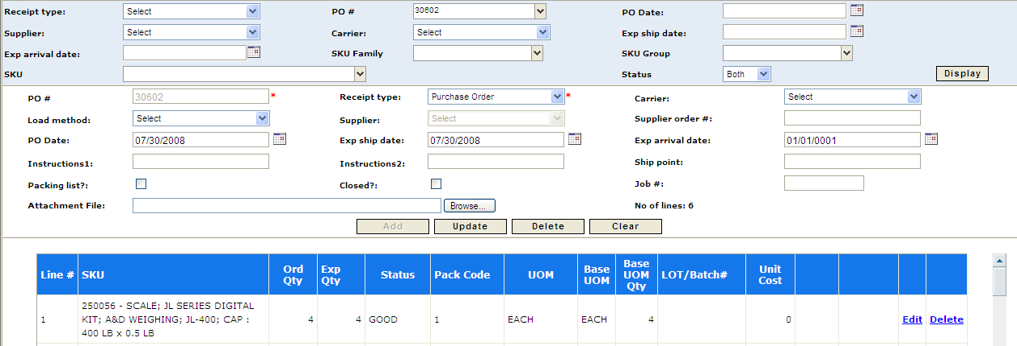

In order to process receipts effectively, all receipt transactions will be assigned a Purchase Order Type. ERP will be responsible for assigning these types to all Purchase Orders that are sent to eBizNET. eBizNET will create receipt records once Purchase Orders are received in eBizNET and will assign a corresponding Receipt Type to these records. The classifications of Purchase Order types for Client are:

Company Code | Receipt Type | Description | Movement To
SS | PO | Purchase Order | SAL
SS | RET | Returns | Depends on Reason Code
SS | SWI | SWAP In | RTM
SS | IMPI | IMPORTS | SAL
SS | RTSI | RTM Stock Transfer In | RTM
SS | STI | Stock Transfer In | SAL

Once the product arrives at the warehouse security check point, security personnel will do preliminary checks to the supplier invoice produced at the security check point and will perform the following activities in eBizNET.

- An Inbound trailer is created with unique trip number. This will be done using “Inbound Trailer creation” screen in eBizNET.
- Once the trailer is created, security personnel will perform the trailer arrival process in eBizNET through “Inbound trailer arrival screen”.
- Why two screens are required. Can it be done in one Screen. What data is captured?
- Yard location is then assigned to the truck to park the vehicle.

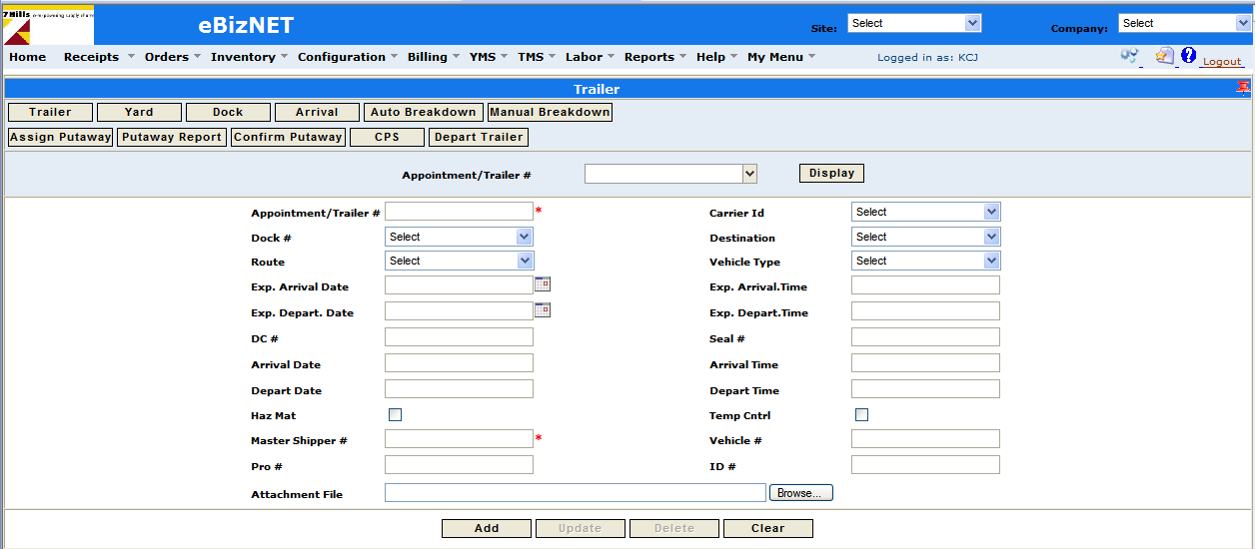

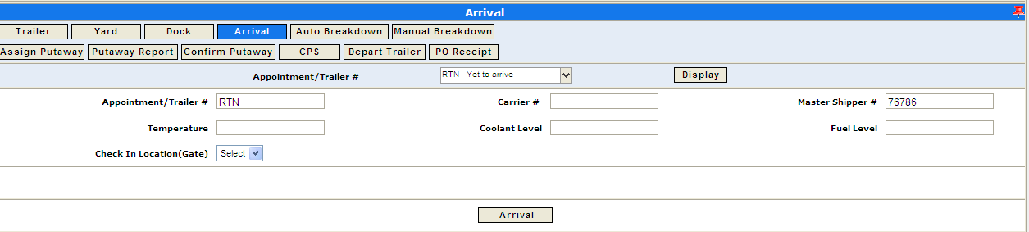

Supplier Invoice copy will then be verified by the Inward operations manager/ supervisor for the required checks. to develop a new screen to incorporate the PO checks in eBizNET. Inward operations manager will verify for the following checks.

- SUPPLIER NAME & CODE
- SUPPLIER DELIVERY STATE/CITY CODE
- SUPPLIER INVOICE NUMBER ( This number is Unique in ERP, Validation needs to be done in WMS)
- SKU/ ERP CODE
- VENDOR PART CODE OF MATERIAL
- DESCRIPTION
- OUTSTANDING QTY
- RATE AT ITEM LEVEL
- TAX AT ITEM LEVEL
- DUE DATE
- TOTAL VALUE
- CURRENCY
- STOCK ROOM IN WHICH IT WILL BE INWARDED

To verify the tax in the PO, tax structure has to be maintained in eBizNET. The tax structure has to be built in eBizNET. The warehouse will not accept even if there is any slight deviation in the PO receipt. In all such cases the material is either returned back or PO in ERP is amended and re downloaded to eBizNET.

If SKU received into the warehouse is not present either in ERP or WMS, then warehouse team has to inform business people. A new SKU is then created in ERP and will be downloaded to eBizNET through SKU download scheduler. The PO will be amended in ERP and will be re downloaded (if already downloaded) and processed out of eBizNET.

When the verification of the PO is complete, then a dock door will be allocated for unloading the material from the truck. Dock door will be allocated through eBizNET screen. For the creation of PO receipt, system rule Id 450“Trailer Receipt” in eBizNET should be set to “Y” for all the sites in eBizNET. A PO receipt is then created by selecting the PO lines and entering a AWB/Docket#/LR # or Bill of Lading number.

Once purchase order is downloaded to eBizNET, receiver will create the PO receipt using “PO Receipt” screen and will then print a palletization report. The palletization report consists of approximate no. of empty pallets and Shelves required to unload the truck and details of the SKU’s that are to be unloaded. This report will not print automatically, but will print on demand. Once done, based on the report, the receiver will print the no. of SKU bar coded labels.

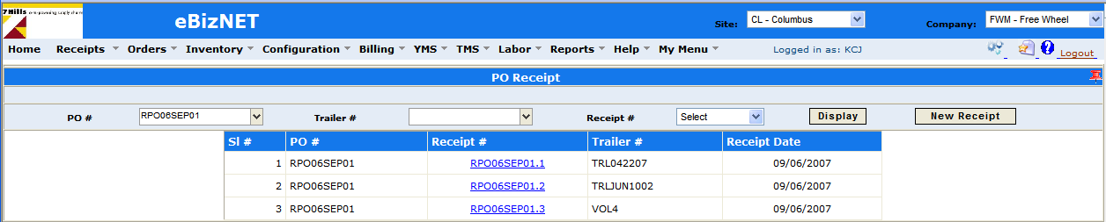

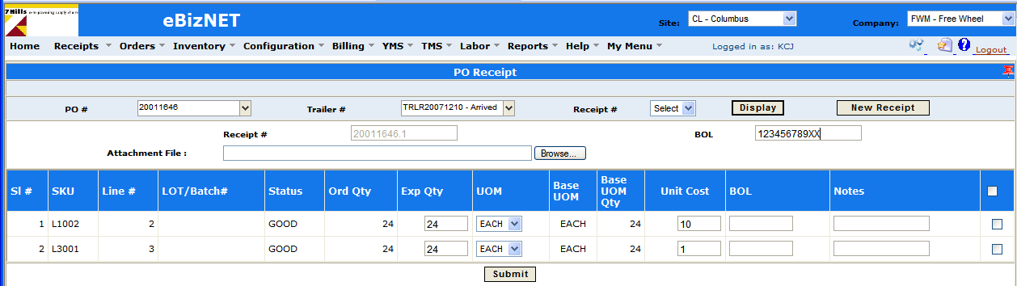

8.2 Check-In and Breakdown through Screen

There are two screens that can be used to perform Breakdown (i.e., Check-In), namely, the MANUAL BREAKDOWN or the AUTO BREAKDOWN screens. Here the Receivers will record what is actually received

MANUAL BREAKDOWN can be used for any items being received. AUTO is used only for those items where a standard pallet configuration exists so that the system can guide the Receiver as to how to build the pallet. For example, AUTO may be a better option for large items like monitors where a known amount will fit on a pallet. MANUAL may be more appropriate for smaller items that are placed in bins. For each item, the Receiver will enter the actual quantity received and assign the quantity to a license plate.

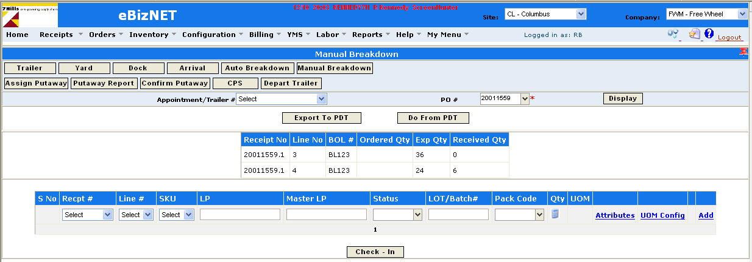

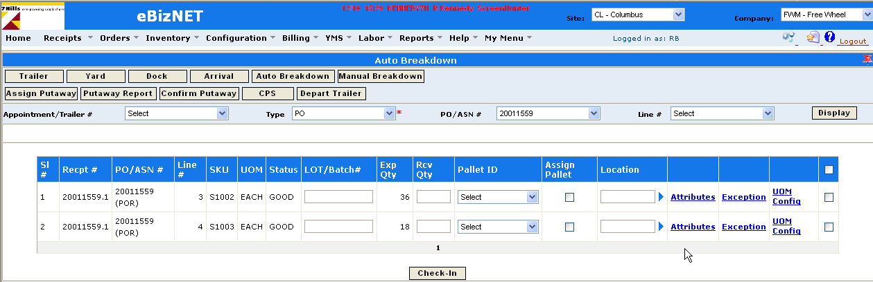

8.3 RF Check-In and Breakdown

Each of the steps for Breakdown described above can be conducted using “Check-In” on an RF terminal. The advantage of the RF is mobility – Receivers can move around the material as they conduct their inspection and Check-In. Using eBizNET, Client always has the option to use either the Breakdown screens or the RF Check-In or a combination of both. In addition to mobility, an advantage of the RF is that the user interface is more “guided” step-by-step, which could be helpful for new employees or cross-training. There is no need to generate or print any receiving labels during the receiving process. The only labels that will be used will be the pre-printed LPs that are required for check in and putaway and they will look similar to the example below:

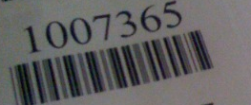

LP ranges will be setup for the inbound and outbound container LPs. To receive items into eBizNET, Client will use RF terminals to check-in product. The receiver will access the RF receiving menu and select CHECK-IN. When prompted to enter the purchase order number, the Receiver will enter the PO receipt number from the PO palletization report. Once the PO receipt number is entered, the receiver will determine which item or SKU to receive.

If the SKU is not listed on the PO Receipt Report, then the system will show an INVALID SKU message and can not be received until it is added to the purchase order and receipt. Client will not permit product to be received unless the product is associated with a PO. The item must be placed aside until it is added to the purchase order in ERP and re downloaded into eBizNET. The SKU along will now be on the PO and then user has to add that SKU to the receipt and then the receiver can proceed with receiving the SKU.

After the SKU barcode is scanned( ERP Code), the quantity received is entered. The Best fit quantity will be estimated based on the LBH and weight data available in the system. Next, serial number scanning, this is only for SKU’s which are serial number controlled.

Next, a unique tracking number, the pre-printed inbound container license plate (LP), is scanned. Unit loads are unique by associating the PO, SKU and quantity to the unique inbound container LP. After scanning/entering the LP, the receiver will scan the pre printed LP which is affixed on the pallet. This is only applicable if there is only one SKU per pallet.

Note: will customize the inbound process to allow Serial Number scanning for the SKU’s while Check in only for the Purchase Orders that are download with RET as the receipt type. Serial number scanning is required only for the returned materials hence, for all the return purchase orders, ERP should pass the receipt types to eBizNET through inbound process.

The unit load is placed onto a pallet ensuring that unit loads are organized and not randomly placed on the pallet. This will expedite the “Put-away” process because all cases will be facing towards the resource putting the product away. After receiving the unit load, the user will have options to enter a new PO receipt, SKU, or quantity if the quantity being received is greater than one pallet. This process will continue until all SKUs on the PO receipt are received.

If required, multiple receivers can receive against the same PO receipt (ASN) at the same time. Purchase Orders can be received against multiple receipts. Sequence of steps performed in RF for Check in process is mentioned below.

1.
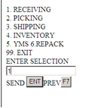

2.

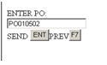

3.
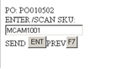

4.

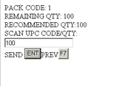

5. May not be required

6.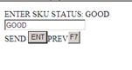

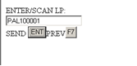

7.
Label Printing is not required in WH
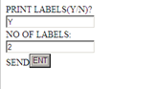

8.

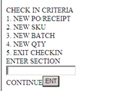

After receiving all the products of the PO receipt, the trailer that is associated with this PO receipt will be departed systematically in eBizNET using “Trailer Depart” screen. When once the trailer is departed the GRN confirmation will flow back to ERP with information on Receipt Qty, due date, Rate at Item level, Item code, tax, dispatch city (state code), currency supplier invoice, PO Number, PO Line number, Receipt number, SKU Status (mentioned in Pg 18 . The GRN will then be printed out of ERP.

SKU’s of the PO receipt that require value addition like sticking MRP labels etc, will be moved to the “Value Addition Area”. This area will be configured as Staging area in eBizNET. Once unloading is done the trailer that is associated with this PO receipt will be departed systematically in eBizNET using “Trailer Depart” screen. Once done, the GRN confirmation will flow back to ERP. The GRN will then be printed out of ERP. For Import Consignments and value addition SKUs, GRN should not get confirmed in WMS until stickering/value addition activities are done.

8.4 “Cross Docking” for Pre-Sold Orders (Backorders)

To track in-transit inventory, Client is considering ‘pre-selling’ products, meaning such purchase orders are already tied to sales orders. Purchase Orders will be entered into ERP and downloaded into eBizNET. When ever, a supervisor/warehouse manager gets a notification about the cross docking order, then a cross dock flag will be checked in PO entry screen in WMS. will provide an option of checking this flag in the new PO verification screen. The purchase orders that are checked with cross dock flag will not be allowed systematically to generate the locations for putaway.

ERP should pass a cross dock flag along with the download of the sales order. This is only for the Sales orders that need to be cross docked. For such orders, when released in a wave, stocks will be allocated for those SKUs in the inbound staging area thus allowing user to pick from staging locations.

Note: Even if a single SKU in purchase order to be cross docked, the entire PO will be checked with cross dock flag and all the SKU’s in that PO will not be allowed to do the putaway.

8.5 Put Away (System Directed) and Storage

Storage locations will be systematically determined and generated based on pre-configured “Put Rules” and “Put Methods”. eBizNET will be configured to determine the “best” available location at the time the SKU is received according to the following logic:

- eBizNET will search for a location containing the same SKU and where the entire new receipt or unit load can be merged and stored within the location, then if no merge opportunities exist (We may need to configure system where no top-up is allowed)
- eBizNET will search for empty locations in the appropriate “Put Zone”, then if no empty locations are available
- eBizNet will search for an empty location outside of the prioritized putaway location group (overflow location).

All putaways will be assigned within the specified putaway sequence. Only one SKU is stored in one location. Putaways will only happen to the Storage locations and not to the Replenishment locations.

- Put Rule

  - Merge
  - Empty

2) Put Method

  - Merge like items/SKUs
  - Merge LPs
  - Empty Location

Other criteria can be used as well based on requirement. In all cases, eBizNET will systematically determine a storage location.

8.5.1 Two Step Putaway

Mostly VNA trucks are operated in VNA rack locations. It is not feasible for the VNA truck operators to pick the pallets from the Inbound staging locations and put it away in the VNA rack locations. Hence, a two step putaway process is followed at Client where in one user will pick the products from the inbound staging locations and deposit in Transfer locations and the other user will pick the product from the “Transfer location” and places the product on the VNA racks.

The transfer of products from the Inbound staging area to Transfer Locations can be done using BOPT or Fork lift trucks.

Transfer locations are pre defined in the system and are tied respectively to the VNA Rack locations. Each VNA Rack location will have a transfer location with two (Three) pallet positions. One location group may be tied to multiple VNA equipments This is a configuration set up and can be changed as and when needed.

8.5.2 Putaway to Transfer Location

When Check in process complete, system will determine the putaway locations by considering Put Methods and Put Rules. While performing Putaway for the LP which is checked in, the system will logically determine a transfer location by considering the end location generated for Putaway and will direct the material handler to respective transfer location. On confirmation of primary movement System will generate a Secondary Putaway task for the respective VNA truck operator. Such tasks can be viewed in RF Open Tasks screen.

Periodically VNA truck operator has to check for the open putaway tasks displayed in the Open tasks screen and perform respective putaway’s.

will develop new screen in RF that will display Open Tasks.

Note: User can only see the putaway tasks of the locations for which the Material handling equipment (VNA truck) is tied to.

8.5.3 Putaway to End location

The actual putaway trip to the End location begins when the user (VNA Truck Operator) checks and accepts the open putaway tasks from the Open Tasks screen in RF. eBizNET will be configured to prompt the user to scan the pre-printed inbound container LP. If the unit load will not fit in the suggested location, the material handler can over-ride the location and place the load into a different location. Over-riding a location should only be considered if and when the material handler is directed to place the same SKU as the SKU that is currently in the storage location but due to inaccurate SKU dimension data, does not fit into the location. (This may not happen as Top-up is not being considered) Even when this situation occurs, it should be brought to a supervisor’s attention in order to correct the SKU or location dimensions to eliminate this problem in the future. Although the over-ride process can be performed, it may not be in Client’s best interest. The system will not direct the material handler to putaway in a location where a different product already exist in that location. Even when this situation occurs, it should be brought to a supervisor’s attention.

In general, Client wants to ensure that heavy weight items are located in easily accessible storage locations. To do so, we will recommend the creation of bulk storage zones within each of the areas. A storage zone is simply a logical grouping of no of location groups based on certain logic. Each location group will have a sequence of adjacent location groups for overflow in situations where no locations are available in the prime location group.

Section 9.0 OUTBOUND OPERATIONS

9.1 Order Processing and Wave Management

The Invoices in ERP will be downloaded as Sales Orders in eBizNET. After Invoices are successfully downloaded into eBizNET, the Invoices will be available for processing. Invoices should be cancelled or deleted from eBizNET only if the order status is EDITED. Data captured in the Invoice with Invoice #, Invoice address, Order type (SO) shipping address, Text ( at item level) SKU, QTY, UOM( each) , Serial #, Freight details, Mode of dispatch ( Exw- TPA/ TPR, DD, STN, OTN ), shipping charges, chargeable weight, volume, CST # ( New data field ), LST #( New data field ). Date of Expiry ( some SKUs)
(Required info:- ERP >>> WMS
Invoice #,
Consignee name & address,
SKU
Qty
Serial No (For serial no controlled material + RTM dly + SWO)
Freight details ( Carrier/courier)
Mode of dispatch (Exw- TPA/ TPR, DD, STN, OTN)
Type (Normal, Stk Trf, Defective,RTM,Swap)

9.2 Wave Creation

To further process and fulfill Invoices, orders will be selected into waves and released for picking via the WAVE CREATION screen. A wave is a group of one or more orders released together for picking and shipping at the same time. Waves are the primary method used for controlling the amount and flow of work through the facility. Generally, orders with similar characteristics are grouped together as a wave for simultaneous processing.

The WAVE CREATION screen will display all available Invoices that have not been selected into a wave, including orders (backorders) containing order lines where inventory is not available. A designated user will select Invoices into waves based upon various parameters such as order number, order type, backorders, order priority, ship date, Route etc… All orders that meet the criteria entered in the Order, SKU, Address Based, or Attribute tabs on the WAVE CREATION screen will be displayed once the Display button is pressed. The user will select which order(s) will be considered for a specific wave by selecting all or some of the orders retrieved via the initial query. Once orders are selected, the wave is generated by pressing the Generate Wave button. If the wave is successfully generated, a message stating Wave Number #### Generated will display in green at the top of the WAVE CREATION screen.

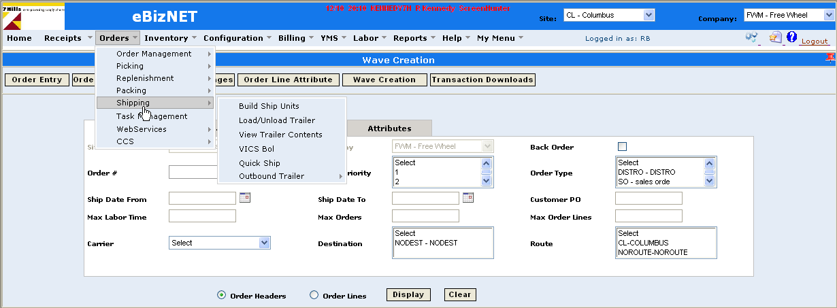
Wave Creation screen

9.3 Wave release

After successfully generating a wave, the wave can be released for further processing by pressing the Release Wave button. If the wave is successfully released for picking, a message stating Pick Generation and Cluster Generation Successful will display.

Stock allocation(Soft Allocation) occurs automatically once an order wave is released. The inventory is allocated and is only available for those orders for which it was allocated meaning that inventory is not available for other orders.

Client will not permit orders to be partially picked nor partially shipped unless approved. Therefore, Invoices will not be released for picking until inventory is available for all order lines on the order. To prevent orders from being partially picked or shipped, system rule 2200 – Short Picks Allowed will be set to N.

Once a wave is released, if inventory is not available for all order lines and all orders, then the message Picks Generation Failed – Inventory not available will display in red at the top of the WAVE CREATION screen. The resource in charge of releasing waves will need to access the WAVE MAINTENANCE screen to remove any order containing items with insufficient inventory from the wave. Orders can be removed from a wave, or the entire wave can be cancelled. In the query block, the user will enter OrderLevel in the Criteria field, the wave number (in which the picks generation failed) in the wave number field, select the Short Picks Flag block and hit Display. All orders containing order lines with insufficient inventory will display. The user will select all orders within the specific wave that contain short picks and will delete those orders from the wave by hitting the Cancel/Delete Orders button. After doing so, only those orders with sufficient inventory are released for picking. After cancellations are successfully performed, the cancelled Invoices return to a status of ‘Edited’ and are again available to be re-selected into a wave in the WAVE CREATION screen.

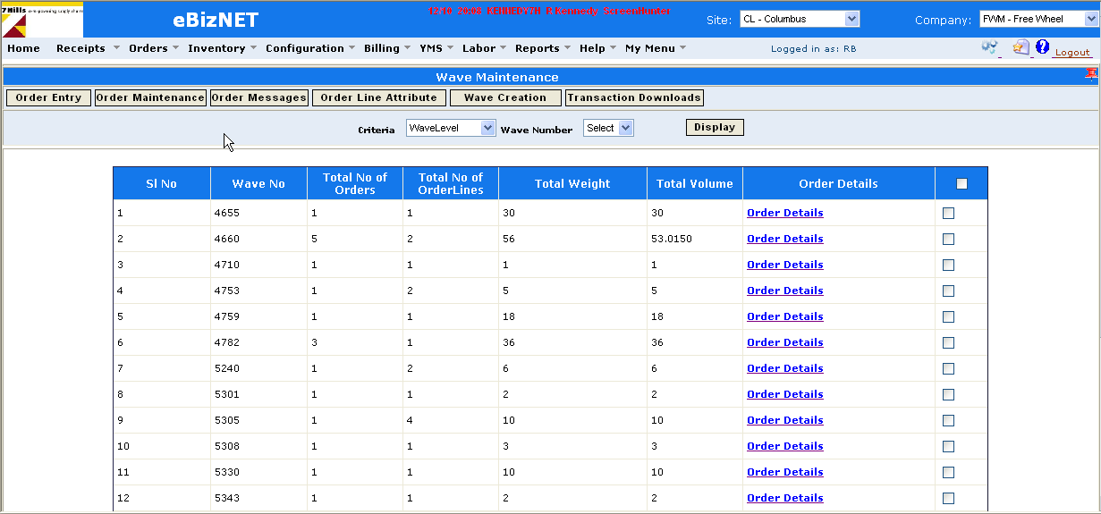
Wave Maintenance screen

After a wave is created, it will be released. When the wave is released, the pick tasks are available for the picker on RF.

Orders will be grouped into clusters and a wave could consist of multiple clusters. A cluster is a grouping of orders assigned to one order picker. The size of a cluster is determined from the pick method and can contain from one to ‘n’ number of orders or containers defined in Pick method. The most efficient cluster size can best be determined by Client. A cluster is only limited by the total number of orders, SKUs or containers that a picker can keep organized while picking (i.e.: the amount an order picker can place onto a transport pallet and take to the pack staging area).

Clusters will be unique to a pick zone and will only contain picks for items within one pick zone. A pick zone is a grouping of pick locations. All orders contained within a cluster will be picked by one order picker by traveling through a pick zone once. Multiple clusters are created if picks are to be assigned for multiple zones.

Once a wave has been successfully released to the floor, to obtain a cluster number, a cluster pick report will be printed (Orders → Picking → Cluster Pick Report). To begin the Cluster Picking process via RF terminals, the order picker is required to select a cluster number from the list.

9.4 Order Picking

The order picker will obtain the wave number/cluster number from a Pick Report/Cluster pick Report which is generated once the wave has been successfully released to the floor for picking. Via RF terminals, Order Pickers will be systematically directed to pick locations for each pick task. eBizNET will use its logic to determine which location to pick from and will sequence the picker on an efficient pick path. The pick sequences will have to be defined during the system configuration. Picks are assigned based on the following configurations.

- Picks are assigned to Replenishment or pick face locations only if the pick quantity is not full pallet quantity or half pallet quantity. This is for Unit/Case picks.
- If the pick assigned for half pallet quantity, then picks are assigned to half pallet locations if half pallet quantities are defined for that SKU. This is for Half pallet picks.
- Picks for the full pallet quantity is always picked from bulk storage locations.

Note: Whenever picks are assigned for Unit/case picks and when no sufficient quantity exists in Replenishment locations then a replenishment task will generate first from Storage locations to Pick face locations thus allowing the order picker to pick (Unit/Case picks) only from pick face locations.

With each pick, Order Pickers will be directed to go to a location, scan the bar coded location address, verify the SKU, pick the necessary quantity, scan the serial numbers picked and place the product into the container and scans the container bar code. The order picker will continue this process until all required picks are completed. Once all picks for an order are picked (confirmed via the RF terminal), the order status will update from partially done to Picks Confirmed. Once picking is completed for the order, the order picker will be directed to take the containers to a staging location in the packing or shipping area. After depositing the containers in the staging area, the picker will then continue the picking process for the next assigned wave/cluster.

Once all the picks are confirmed for the order, confirmation details are sent to the ERP (integration point). Below are the sequences of steps for picking in RF.

1.
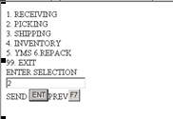
2.
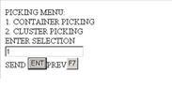
3.
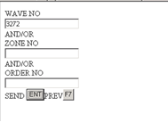
4.
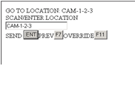
5.

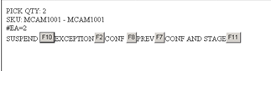

6.
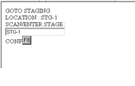

9.4.1 Two Step Picking

Two Step Picking process is followed at Client wherein one user will pick the products from the VNA locations and deposit in Transfer locations and the other user will pick the product from the Transfer location and deposit in the Outbound staging area.

9.4.2 Picking from Bulk Location to Transfer Location

The VNA truck operator will select the wave number from the list in RF pick screen. With each pick, Order Pickers will be directed to go to a location, scan the bar coded location address, verify the SKU, pick the necessary quantity, scan the serial number (if required), and also scan the pre-printed LP of the pallet and deposit the pallet to the Transfer Location. The order picker will continue this process until all required picks are completed.

9.4.3 Picking from Transfer location to Staging Location

After the pallet is deposited in the transfer location, and when the material handler scans the ContLp that is affixed to the pallet in the transfer location, system will direct the material handler to deposit the pallet to the Outbound staging location.

If picks are assigned to multiple zones then multiple cluster numbers are generated when released the wave. In such situations, different users picks the SKU’s from different zones but will be directed to the same Outbound staging location.

Serial Number and Batch numbers are to be captured after picking. Master case ID tracking also to be enabled.

Master Serial ID scanning at Inbound and Outbound. For a few SKUs serial number data with master serial / Case ID information needs to be uploaded in WMS thru a CSV file. The complete functional requirement will be communicated later. At inbound this master ID scanning is done before GRN confirmation. Similarly Case ID scanning is done for out bound dispatches. For handling SKUs less than case quantities individual serial numbers are scanned at inbound and outbound.

9.5 Packing

Once all the picking activity is done for that order, the order status is now updated to picks confirmed. User has to print the packing slip for the order. Once done, confirmation is sent to the ERP with details Invoice #, Invoice Line #, SKU, Qty, Serial #’s, Status. Now, print the Invoice from ERP.

All the orders with Picks Confirmed status are now available in the eBizNET build Ship units screen. User has to choose all the orders that needs to be shipped in a particular container and generate build ship units.

9.6 Shipping

Once the outbound truck that carries the goods (orders) arrives at the security check point, security personnel have to create outbound trailer with a unique trailer id. The trailer then has to be arrived using trailer arrival screen in eBizNET. Once done, the truck will be allowed to park in the yard. Once an outbound dock door is assigned to the truck, material handlers have to load the orders into the trailer through Load trailer screen in eBizNET. The orders will then be loaded into the truck physically by the material handlers. Once loaded onto the trailer, Bill Lading will be printed out of eBizNET. The containers and orders are now available to be shipped. Once trailer departed then a confirmation needs to be sent to the ERP using the CSV file. The following are the fields updated in ERP..

- Invoice #
- Trip #
- No of Boxes
- GCN # (PRO #)
- Date of Dispatch
- Courier Code(Carrier id)
- Status

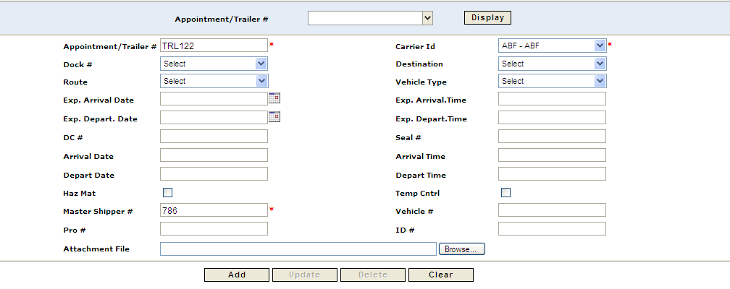
Outbound Trailer creation

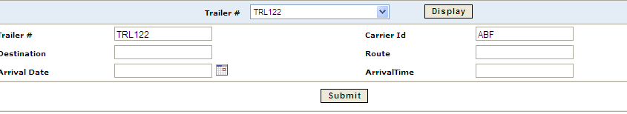
Outbound trailer Arrival screen

As a continuing process, system will identify the mode of dispatch which are categorized as below. Trip sheet is generated with in eBizNET.

- Prepaid (Road and Air)
    - Within the city
    - Outside the city
- To pay (Air and Road)
- Ex ware house
- Outstation Delivery (Road Only)
- Door Delivery (Road Only)
- Stock Transfer (Road, Air, Train)
- RTM (Sea, Road, Air)
- Swap (Advanced, Post)

In the case of prepaid delivery, eBizNET will check for the destination of the delivery. If it is within city, user has to generate trip sheet and in the case of Outside the city, To pay RTM , Stock Transfers, Door Deliveries, Swap consignment has to be shipped through transporter or courier.

In case of the dispatch through the trip sheet (Door Deliveries and Pre-paid within the same city), multiple dispatches can be clubbed. For Stock Transfers and Outstation deliveries multiple dispatches can be clubbed for the same consignee. This will be done using carrier determination screen. Once the route is finalized, the truck is departed out of the dock. The trailer is then departed in eBizNET. Once done, eBizNET will then send the confirmation to ERP.
Once delivered to the customer, ebizNET will again send confirmation to ERP with details Order number (Invoice Number of ERP), Date of Delivery, Status, Notes1.

On delivery of the product, system will identify the delivery status. If the product is not delivered to the destination and if it is brought back, the material will be brought back to warehouse and will be inwarded. This order will be planned along with the next delivery. In case of delivery by other mode, system will update the way bill number. Once the updating and delivery status is confirmed, the system will update the proof of delivery (POD) to ERP.
POD will contain following details

POD Confirmation (WMS >>> ERP)

- Invoice Number
- Date of Delivery(WITH TIME)_
- Status
- Notes1(Receiving person)
- Reason for late delivery Screen to update TAT (Invoice time to Delivery Time) for each warehouse.

Section 10.0 CYCLE COUNTING AND INVENTORY
MANAGEMENT

10.1 Cycle Counting
Client will complete cycle counting by establishing cycle count rules, creating a cycle count plan, generating and releasing the plan, performing the actual cycle counts via RF terminals, and resolving the cycle count plan. Client will create cycle count rules via the CYCLE COUNT RULE SETUP screen. Specific SKU Families, SKU Groups, SKUs, location groups, locations, etc… can be assigned to a specific cycle count rule. Client will create a cycle count plan via the CYCLE COUNT PLAN – CREATE screen. The plan is created by taking the rule into consideration and can be created for a specific Rule ID, location group, location, SKU, etc… Every plan is assigned a unique plan number. Once the cycle count plan is created, the plan needs to be generated and released to perform the actual cycle counts. Cycle Count Plans are generated and Released via the GENERATE AND RELEASE CYCLE COUNT PLAN screen. A plan is generated by simply entering the plan number, device type (RF) and hitting the Generate or Gen & Rel button. Plans can be generated and released at a later time or the plan can be generated and released simultaneously.

To execute and perform the actual cycle counts for a specific plan, the plan number must be selected from the list in a RF terminal. The cycle counter will be systematically directed to specific locations. Upon reaching the location, the user is prompted to scan the location, scan the actual LP in that location, verify the SKU and enter the actual quantity. This process is repeated until all counts are completed. Users with RF terminal can initiate a cycle count and confirm the quantity. Also when any location becomes empty after pick, users to reconfirm the same and complete a cycle count.

Once all counts for a specific plan are completed, the cycle count plan can be resolved via the CYCLE COUNT RESOLVE screen. Specific records or the entire cycle count plan can be Ignored, Recounted or Accepted. A supervisor or manager can accept a specific record or entire plan if the actual and expected value(s) match. If discrepancies exist between expected and actual values, then a supervisor or manager can either choose to ignore the specific count or entire plan, or have the specific item(s) or plan recounted or accept the discrepancy for the specific item(s) or plan. If determined to recount a specific item or the entire plan, the items selected to be recounted will be available to the Client personnel to re-record the details via RF.

Once the record or cycle count plan is accepted, an inventory adjustment is created. ERP would then be checked for the inventory and will then be amended in ERP to match with the inventory in eBizNET. Sequence of steps followed in eBizNET screens and RF are:

1.
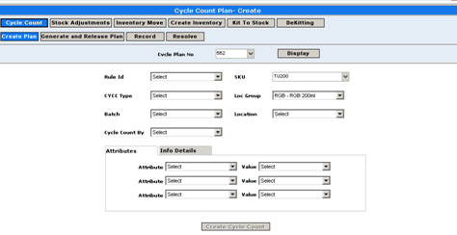
Then, using RF
2.
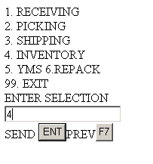
3.
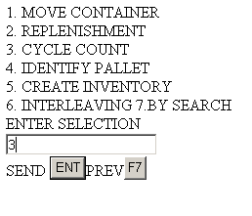

4. Option for user so see plan numbers …. Help on pending plan numbers
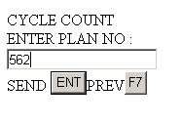

5.
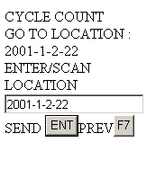
6.
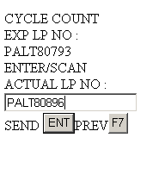
7.
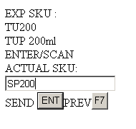
8.
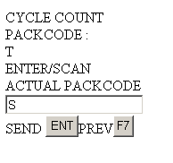
9.
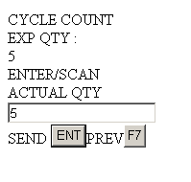

10.
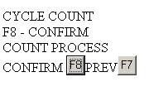
11.
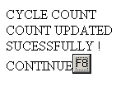

10.2 Replenishments

Replenishments will be required at Client because Unit/Case pick products will be picked from locations assigned to fixed pick lines. Also known as a forward pick line or a replenished pick line, this is where smaller than pallet quantities are picked for products, which are assigned a pick location. SKUs are dynamically assigned to locations on the pick line. Locations on the Fixed Pick Line may be called Fixed Pick Location or Pick Faces. These locations are replenished from the storage when the quantities drop below a designated quantity as defined per product. All products will be randomly and dynamically stored and picked from storage locations.

10.3 Inventory Management
Inventory Management considers various required job functions such as moving containers or inventory from one location to another, identifying inventory, adjusting or creating inventory, changing information such as SKU, status or an LP. Whatever the requirement, these tasks can be completed via GUI screens or RF terminals. For example, if a specific SKU or LP is misplaced, the actual location(s) (the current location in eBizNET) can be obtained by entering the LP or SKU. The specific location for the LP will be provided or all of the locations and current quantity in each of the locations where the SKU currently exists will be displayed. If required, containers or inventory can be moved from one location to another. If inventory is found (no record of the specific SKU or quantity currently in eBizNET), this is resolved thru PO in ERP and GRN in WMS. Through these available inventory management screens, adjusting or locating inventory is simplified.

10.3.1 Stock transfers

10.3.1.1 Outbound process

Stock transfers to other warehouses will follow the same process as outbound (Sales order process) in eBizNET.

After Stock transfer notes(STO) are downloaded into eBizNET, the Stock transfer notes will be available for processing through Sales order entry screen. The stock transfers are downloaded from ERP to eBizNET with a different order type (STO). ERP should send this information to eBizNET. Stock transfer notes should be cancelled or deleted from eBizNET only if the status is EDITED. Data captured in the Stock transfer note with details stock transfer note number, Consignee Details (Consignee ID, Address, City, State, Pin Code, Country), Line number, SKU ,Batch/Lot, Qty ,Serial # , Freight Details (Carrier), Mode of Dispatch (Road, Air, Train), Order Type. ST Reference #.

10.3.1.2 Wave Creation

To further process and fulfill Stock transfer notes, stock transfer notes will be selected into waves and released for picking via the WAVE CREATION screen. Stock transfer notes can be identified by selecting the order type (STO) in wave creation screen thus allowing user to release wave only for stock transfer notes. The process to create a wave is as mentioned in section 9.2

10.3.1.3 Wave release

The process to release waves for Stock transfer notes is as mentioned in section 9.3 above.

10.3.1.4 Stock transfer note Picking

Picking stock transfers is as mentioned in section 9.4 above. Serial number scanning for stock transfers out bound process is required

10.3.1.5 Stock transfer note Shipping

Stock transfer note Shipping is as mentioned in section 9.5 above. Customization should be done in eBizNET to remove stock transfer notes from the Trip sheet screen.

10.3.2 Inbound process

The stock transfers from other warehouses to WH site are downloaded to eBizNET as standard PO downloads but with different PO type (STI). The process of in warding the goods will follow as mentioned in Section 8.0 and its sub sections.

Section 11.0 REVERSAL (RRLC)

11.1 Reversal

The orders that are dispatched to the customers may be returned back to Client in some situations. Based on the information from the customer, RRLC process is initiated by business. An R number in the ERP is generated and sent to WMS only after authorization in ERP .This RTN document is downloaded by the eBizNET as PO with a different PO type with information details Return number, SKU, Qty, Origin(City), Sales Order number, Stock Room. Information on stock room will be downloaded to notes field.

Standard in ward process is followed as mentioned in Section 8.0 and its sub sections. Serial number scanning is required while in warding the goods in this process.

This process of in warding is followed when the order is dispatched to the customer and is returned back to the warehouse.

11.2 Sales Order Cancellations

Sales Orders that are being processed in the warehouse can be cancelled by the Client’s customers at any stage.

Sales orders in eBizNET can directly be cancelled only when the status of the order is Edit. User has to follow certain process in eBizNET to cancel the order depending on the stage or status of the order. Orders with the status of Shipped can not be cancelled in eBizNET. Such orders have to be processed as standard inward process mentioned in Section 8.0 and its sub sections.

Sales orders for which wave is created (not released to floor) will have an order status of Wave generated in eBizNET. If such orders have to be cancelled in ebizNET, then user has to delete the order from the wave by using Wave maintenance screen. In wave maintenance screen, select the wave criteria as order level and display after selecting the order number. Select the order that needs to be cancelled and Cancel/delete the order from the wave. After cancelling the order from the wave, the order will now hold a status of Edit. User can now go to the Sales order entry screen, select the order number and can cancel the order.

Sales orders that are released in wave will have an order status of Piks generated in eBizNET. If such orders have to be cancelled in ebizNET, then user has to delete the order from the wave by using Wave maintenance screen. In wave maintenance screen, select the wave criteria as order level and display after selecting the order number. Cancel/delete the order from the wave. After cancelling the order from the wave, the order will now hold a status of Edit. User can now go to the Sales order entry screen, select the order number and can cancel.

Sales orders that are in the process of Picking and completed picking will have an order status of Partial done and Picks confirmed respectively in eBizNET. If such orders have to be cancelled in eBizNET, then user has to put back/move the items and quantities that are picked to the locations where they picked from using container management screen. After putting back to the locations, user has to cancel the order from the wave using Wave maintenance screen. After cancelling the order from the wave, the order will now hold a status of Edit. User can now go to the Sales order entry screen, select the order number and can cancel.

Note: Sales orders with Shipped status can not be cancelled in eBizNET.

11.3 Swapping

Swapping of products that are sold has to be followed though Inward process and Outward process as mentioned in Section 8.0 (and sub sections) and Section 9.0 (and sub sections) respectively. Purchase order is created in ERP and will be downloaded to eBizNET with a different PO type. A standard inward process is followed in eBizNET as mentioned in Section 8.0 and its sub sections to inward the received material. Invoice will be generated in ERP and will be downloaded to eBizNET as sales order with a different order type. A standard outward process as mentioned in Section 9.0 and its sub sections is followed in eBizNET to swap the product that was returned. For Swap process ERP will give the details of the SKU. Thru integration WMS will first generate an Swap SO and a SWAP PO. If Serial numbers do not match at the time of delivery, SWAP PO type to be changed to normal Sales Return/Reversal to bring the stock back to Saleable (1/8 stockroom) All SWAP PO receipts will move the stock to RTM stockroom (7)

For delivery, dispatch and receipt no integration touch points to ERP

Inventory Moves:

Noombal warehouse will be configured as 3 different zones in eBizNET

CS - Chennai WH – Local Market or within Tamil Nadu
TS - Chennai Mother warehouse
ts – Non II products (white goods)

TS zone is further divided into different location groups in eBizNET in order to have visibility on the movement of stocks. Refer Section 4.0

T0 -- Receiving Stock Room
T1 -- Normal Sales
T2 -- Defective
T3 -- Sales Return
T4 -- Modvat Stockroom
T5 -- Back to Back
T6 -- Insurance
T7 -- RTM
T8 --Tax Paid stock ( Local procurement)

Goods may be moved from one location group to another location group. The inventory moves are created by the supervisor by selecting the item, serial number, To location, From location and quantity to be moved. This can either be done through eBizNET screens or via RF terminal. When once the inventory movement is created, material handler will then physically move the goods and confirms the move by scanning the From Location in RF. Once done, eBizNET will then send the confirmation of the move to ERP , then stock will be moved from one location group to another location group in ERP.
(Internal Stock Movement form/to saleable and non-saleable, Movement within 1,5,8 will not have any impact in WMS) This should be a restricted option in ERP.

For movements from one zone to the other (saleable, damaged, RTM, modvat etc), tasks will be initiated and completed in WMS first and confirmed in ERP thru integration. Invoices from damaged stockroom to be enabled in ERP for CS, TS and tS stockroom site. Inter zone movement will need a reason code or list of values. This will decide to which location the SKU needs to be moved in ERP.

Additional Functionality to be mapped.

- Expiry date control of products need to be handled.
- For SKUs that have multiple packaging but a single ERP Code, the packages will be kept together always and the sum of volume will be captured in the system. (Eg. Servers, UPS etc)

Section 12.0 Enhancements

- Downloading Bill Of Material items (Kit Master) to eBizNET from ERP
- Inventory moves within one stock room to another in eBizNET should confirm to ERP. This is for WH
- Check digit in Location labels
- Cluster Number, Task number, Wave number, order number for picking and putaway will be given to the users. Users will have them listed in the RF terminal so that they can select from the list to start an activity.
- SKU Type should be included in Put rule and Pick rule. Rules based on SKU type.
- Create SKU dimensions based on the palletization report for a new SKU.
- Ability to check a flag in Purchase Order entry screen for cross dock
- New screen to perform Purchase Order validations in eBizNET.
- Tax Logic (Tax master) should be built in eBizNET for Tax validations in Purchase Order validation screen.
- Two Step Putaway.
- Two Step Picking.
- Priority putaway to the replenishment locations with FIFO policy.
- Serial number scanning for Purchase Orders downloaded from ERP based on receipt Types.
- Delivery modes – Should be calculated based on the routes. Pin codes are maintained in eBizNET.
- Removal of empty pallets from the locations.
- Trip sheet for cancellations/updation and late delivery reason.
- Only one MHE in any Aisle at any point of time.
- Second level authorization is required in cycle counting.
- Using RF terminal users can initiate a cycle count adhoc and confirm the quantity. (Nice to have)

Reports:-
- No of times ABC category of materials has been counted at a particular period of time.
- Max and min number of times SKU has been classified as ABC.
- Customer wise dispatch details with serial number.
- Service level based on dispatch/delivery details, TAT.
- Facility utilization report- Should provide details like date, Time, SKU wise as well as customer(3PL) wise.
Stock on a particular date (Old data) with status

CYCLE COUNT FOR TOUCHED ITEMS:-

WMS will support the functionality of counting the materials which has been touched in last user defined days.

REPORTS

9.1 Inbound Reports
Client will use the following Inbound or Receiving Reports:

- PO Check-In Report : Receivers will use this report to check-in or receive items into eBizNET. The PO Check-In report will provide the SKU, SKU description and order quantity.
- PO Status Report: In addition to providing PO header information such as PO number, status and type, and supplier, this report provides order line information such as SKU, SKU status, quantity ordered, quantity received, the quantity where a storage location has been generated (PutGen Qty) and the quantity confirmed to its determined storage location (PutConf Qty).
- Putaway Details Report: This report provides the PO number, SKU, quantity and date for all items putaway within a specified date range.
- Palletization Report: This report provides the PO number, SKU, quantity of all the PO lines, approximate no of empty pallets required to unload the truck.
- Expected day-wise or week-wise delivery of ASN

9.2 Picking, Packing and Shipping Reports
The following picking, packing and shipping reports are available:

- Cluster Pick Report: Used to obtained the cluster # that must be entered when performing cluster picking via RF terminals.
- Order Status Report: Provides information such as order status (Edited, Picks Generated, Picks Confirmed, Shipped, etc…), carrier, shipped date, and order line information such as order quantity, picked quantity and shipped quantity
- Open Picks Report: For a specific wave or order number, this report will display all open or remaining picks. An excellent management tool to insure that orders and waves are completely picked.
- Shipping Details Report: Displays order number, container number, tracking number, freight charges and container weight and the date shipped for a specific order or container.
- Pack Report Standard (Pack List): The standard order packlist providing order number, carrier, Ship To address, SKU, container LP, order quantity and shipped quantity
- Order Shipping Details Report: Can obtain information order, SKU, carrier, shipped quantity for a specific tracking number, order number, or container. Also can provide above information for a specified date range.
- Order shipment after cut-offtime
- Product Shelf Life report

9.3 Inventory Reports
The following inventory reports are available:

- Stock Analysis by SKU: This report provides the allocated, available and total quantity for a specific inventory status (inbound, Storage, or outbound). Also indicates total pending picks for a specified SKU.
- Stock Analysis by Location: Depending on the information specified in the query block, this report will display information such as allocated, available and total quantity, specific license plate numbers, locations, and SKU for a specified SKU or location.
- SKU History Report: Provides SKU History such as task type, location, and the date that the specific task was performed for a specified SKU over a specified date range.

Enquiries

Locations Allocated not picked

Item wise locations

Warehouse utilization map

Empty locations

Locked locations
DASH BOARD FOR DAILY QUIRIES
.
Additional enquiry screens may be required.

